- Introduction
HTML, or Hyper Text Markup Language, is the standard markup language used to create and design web pages. It forms the backbone of web content by structuring and presenting information on the internet.
- HTML describes the structure of a Web page.
- HTML consists of a series of elements. Each element has a purpose. such as show a heading, paragraph, image, etc.
- HTML elements tell the browser how to display the content.

A Simple HTML Document.
<!DOCTYPE html>
<html>
<head>
<title>Page Title</title>
</head>
<body>

<h1>My First Heading</h1>
<p>My first paragraph.</p>

</body>
</html>

Example Explained
- The <!DOCTYPE html> declaration defines that this document is an HTML5 document.
- The <html> element is the root element of an HTML page.
- The <head> element contains meta information about the HTML page.
- The <title> element specifies a title for the HTML page (which is shown in the browser's title bar or in the page's tab).
- The <body> element defines the document's body, and is a container for all the visible contents, such as headings, paragraphs, images, hyperlinks, tables, lists, etc.
- The <h1> element defines a large heading.
- The <p> element defines a paragraph.

What is an HTML Element?
HTML document is structured using a series of elements. HTML elements tell the browser how to display the content. Each element has a purpose. such as show a heading, paragraph, image, etc.
- An HTML element is defined by a start tag, some content, and an end tag.
- Tag format:
<tagname> Content goes here... </tagname>
Examples:
<h1>My First Heading</h1>
<p>My first paragraph.</p>

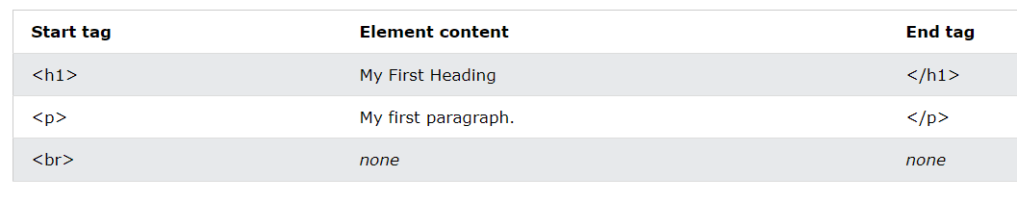
- The HTML element is everything from the start tag to the end tag. The opening tag and its closing tag together specify a container for the content they enclose.

- Empty HTML Elements: Some HTML elements have no content (like the <br> element). These elements are called empty elements. Empty elements do not have an end tag!

- Never Skip the End Tag: Some HTML elements will display correctly, even if you forget the end tag: However, never rely on this! Unexpected results and errors may occur if you forget the end tag!

- HTML is Not Case Sensitive: HTML tags are not case sensitive: <P> means the same as <p>. The HTML standard does not require lowercase tags, but W3C recommends lowercase in HTML.

- Nested elements: HTML elements can be nested (this means that elements can contain other elements). All HTML documents consist of nested HTML elements. The following example contains four HTML elements (<html>, <body>, <h1> and <p>):
<!DOCTYPE html>
<html>
<body>
<h1>My First Heading</h1>
<p>My first paragraph.</p>
</body>
</html>

Example Explained
- The <html> element is the root element, and it defines the whole HTML document. It has a start tag <html> and an end tag </html>.
- Then, inside the <html> element there is a <body> element. The <body> element defines the document's body. It has a start tag <body> and an end tag </body>.
- Then, inside the <body> element there are two other elements: <h1> and <p>
- The <h1> element defines a heading. It has a start tag <h1> and an end tag </h1>
- The <p> element defines a paragraph. It has a start tag <p> and an end tag </p>:

Web Browsers
- The purpose of a web browser (Chrome, Edge, Firefox, Safari) is to read HTML documents and display them correctly.
- A browser does not display the HTML tags but uses them to determine how to display the document.

HTML Page Structure
Below is a visualization of an HTML page structure:
Note: The content inside the <body> section will be displayed in a browser. The content inside the <title> element will be shown in the browser's title bar or in the page's tab.
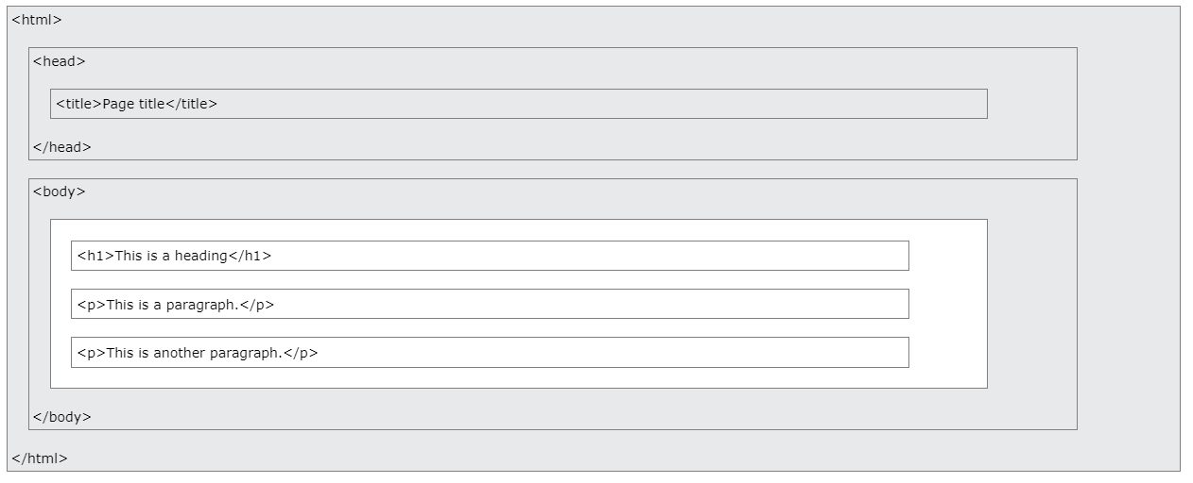
HTML History
Since the early days of the World Wide Web, there have been many versions of HTML:
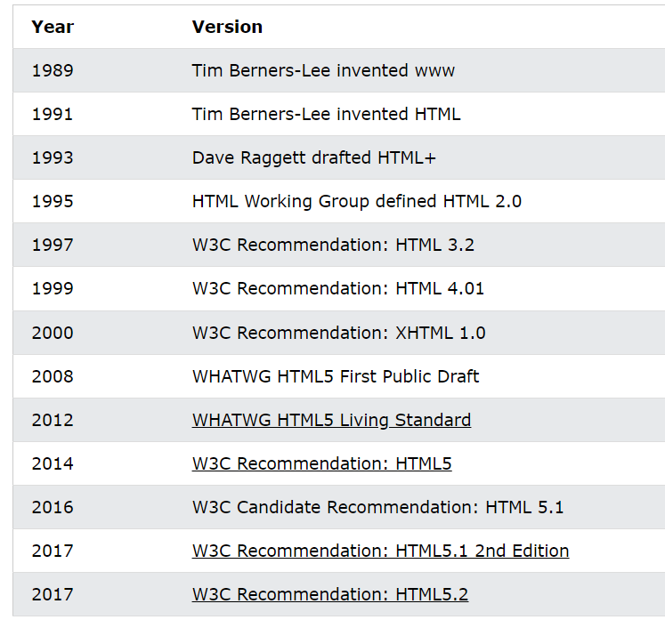
HTML Editors
Web pages can be created and modified by a simple text editor like Notepad (PC) or TextEdit (Mac) or by using professional HTML editors.
In this class we will use Visual Studio Code, you can download VSC from this link: https://code.visualstudio.com/
Feel free to use any other editors.
HTML Documents
- All HTML documents must start with a document type declaration: <!DOCTYPE html>.
- The HTML document itself begins with <html> and ends with </html>.
- The visible part of the HTML document is between <body> and </body>.
- The <!DOCTYPE> declaration represents the document type and helps browsers to display web pages correctly. It must only appear once, at the top of the page (before any HTML tags).
- The <!DOCTYPE> declaration is not case sensitive.
How to View HTML Source
- Click CTRL + U in an HTML page, or right-click on the page and select "View Page Source". This will open a new tab containing the HTML source code of the page.
- Right-click on an element (or a blank area), and choose "Inspect" to see what elements are made up of (you will see both the HTML and the CSS). You can also edit the HTML or CSS on-the-fly in the Elements or Styles panel that opens.
HTML Comments
- HTML comments are not displayed in the browser, but they can help document your HTML source code.
- You can add comments to your HTML source by using the following syntax:
<!-- Write your comments here -->
- Heading
HTML headings are titles or subtitles that you want to display on a webpage.
- Search engines use the headings to index the structure and content of your web pages.
- Users often skim a page by its headings. It is important to use headings to show the document structure.
- <h1> headings should be used for main headings, followed by <h2> headings, then the less important <h3>, and so on.
- Browsers automatically add some white space (a margin) before and after a heading.
- Each HTML heading has a default size. However, you can specify the size for any heading with the style attribute, using the CSS font-size property (to be covered in chapter3):
<h1 style="font-size:60px;">Heading 1</h1>
- Note: Use HTML headings for headings only. Don't use headings to make text BIG or bold.

<h1>Heading 1</h1>
<h2>Heading 2</h2>
<h3>Heading 3</h3>
<h4>Heading 4</h4>
<h5>Heading 5</h5>
<h6>Heading 6</h6>

- Paragraph
Text is normally placed in paragraph elements.
- The HTML <p> element defines a paragraph.
- A paragraph always starts on a new line, and browsers automatically add some white space (a margin) before and after a paragraph.

<p>This is a paragraph.</p>
<p>This is another paragraph.</p>

- You cannot be sure how HTML will be displayed. Large or small screens, and resized windows will create different results.
- With HTML, you cannot change the display by adding extra spaces or extra lines in your HTML code. The browser will automatically remove any extra spaces and lines when the page is displayed:

<p>
This paragraph
contains a lot of lines
in the source code,
but the browser
ignores it.
</p>
<p>
This paragraph
contains a lot of spaces
in the source code,
but the browser
ignores it.
</p>

Solution - The HTML <pre> Element
- The HTML <pre> element defines preformatted text.
- The text inside a <pre> element is displayed in a fixed-width font (usually Courier), and it preserves both spaces and line breaks.
<pre>
My Bonnie lies over the ocean.

My Bonnie lies over the sea.

My Bonnie lies over the ocean.

Oh, bring back my Bonnie to me.
</pre>

- Line Breaks and Horizontal
- The HTML <br> element defines a line break.
- Use <br> if you want a line break (a new line) without starting a new paragraph.
- The <br> tag is an empty tag, which means that it has no end tag.
<p>This is<br>a paragraph<br>with line breaks.</p>

- The <hr> tag defines a thematic break in an HTML page and is most often displayed as a horizontal rule.
- The <hr> element is used to separate content (or define a change) in an HTML page.
- The <hr> tag is an empty tag, which means that it has no end tag.
<h1>This is heading 1</h1>
<p>This is some text.</p>
<hr>
<h2>This is heading 2</h2>
<p>This is some other text.</p>
<hr>

- Text Formatting
HTML contains several elements for defining text with a special meaning.
Formatting elements were designed to display special types of text:
- <b> - Bold text
- <strong> - Important text
- <i> - Italic text
- <em> - Emphasized text
- <mark> - Marked text
- <small> - Smaller text
- <del> - Deleted text
- <ins> - Inserted text
- <sub> - Subscript text
- <sup> - Superscript text

HTML <b> and <strong> Elements
- The HTML <b> element defines bold text, without any extra importance.
- The HTML <strong> element defines text with strong importance. The content inside is typically displayed in bold.
<p><b>This text is bold.</b></p>
<p><strong>This text is important!</strong></p>

HTML <i> and <em> Elements
- The HTML <i> element defines italic text.
- Tip: The <i> tag is often used to indicate a technical term, a phrase from another language, a thought, a ship name, etc
- The HTML <em> element defines emphasized text. The content inside is typically displayed in italic.
- Tip: A screen reader will pronounce the words in <em> with an emphasis, using verbal stress.
<p><i>This text is italic.</i></p>
<p><em>This text is emphasized.</em></p>

HTML <small> Element
- The HTML <small> element defines smaller text:
<p><small>This is some smaller text.</small></p>

HTML <mark> Element
- The HTML <mark> element defines text that should be marked or highlighted:
<p>Do not forget to buy <mark>milk</mark> today.</p>

HTML <del> Element
- The HTML <del> element defines text that has been deleted from a document. Browsers will usually strike a line through deleted text:
<p>My favorite color is <del>blue</del> red.</p>

HTML <ins> Element
- The HTML <ins> element defines a text that has been inserted into a document. Browsers will usually underline inserted text:
<p>My favorite color is <del>blue</del> <ins>red</ins>.</p>

HTML <sub> Element
- The HTML <sub> element defines subscript text. Subscript text appears half a character below the normal line, and is sometimes rendered in a smaller font. Subscript text can be used for chemical formulas, like H₂O:
<p>This is <sub>subscripted</sub> text.</p

HTML <sup> Element
- The HTML <sup> element defines superscript text. Superscript text appears half a character above the normal line, and is sometimes rendered in a smaller font. Superscript text can be used for footnotes, like WWW^{[1]}:
<p>This is <sup>superscripted</sup> text.</p>

- HTML Quotation and Citation Elements
Quotation and citation elements provide structure to quotes and references.

HTML <blockquote> for Quotations
- The HTML <blockquote> element defines a section that is quoted from another source. Browsers usually indent <blockquote> elements.
<p>This is text.</p>
<blockquote >
For 60 years, WWF has worked to help people and nature thrive. As the world's leading conservation organization, WWF works in nearly 100 countries. At every level, we collaborate with people around the world to develop and deliver innovative solutions that protect communities, wildlife, and the places in which they live.
</blockquote>

HTML <q> for Short Quotations
- The HTML <q> tag defines a short quotation. Browsers normally insert quotation marks around the quotation.
<p>WWF's goal is to: <q>Build a future where people live in harmony with nature.</q></p>

HTML <abbr> for Abbreviations
- The HTML <abbr> tag defines an abbreviation or an acronym, like "HTML", "CSS", "Mr.", "Dr.", "ASAP", "ATM". Marking abbreviations can give useful information to browsers, translation systems and search-engines.
<p>The <abbr title="World Health Organization">WHO</abbr> was founded in 1948.</p>

HTML <address> for Contact Information
- The HTML <address> tag defines the contact information for the author/owner of a document or an article. The contact information can be an email address, URL, physical address, phone number, social media handle, etc.
- The text in the <address> element usually renders in italic, and browsers will always add a line break before and after the <address> element.
<address>
Written by John Doe.<br>
Visit us at:<br>
Example.com<br>
Box 564, Disneyland<br>
USA
</address>

HTML <cite> for Work Title
- The HTML <cite> tag defines the title of a creative work (e.g. a book, a poem, a song, a movie, a painting, a sculpture, etc.). Note: A person's name is not the title of a work.
- The text in the <cite> element usually renders in italic.
<p><cite>The Scream</cite> by Edvard Munch. Painted in 1893.</p>

- Character Entities
Some characters are reserved in HTML. If you use the less than (<) or greater than (>) signs in your HTML text, the browser might mix them with tags.
- Entity names or entity numbers can be used to display reserved HTML characters.
- Entity names look like this: &entity_name;
- Entity numbers look like this: &#entity_number;
- Example: To display a less than sign (<) we must write: &lt; or &#60;
Note: Entity names are case sensitive.
Note: Entity names are easier to remember than entity numbers.

Some Useful HTML Character Entities:

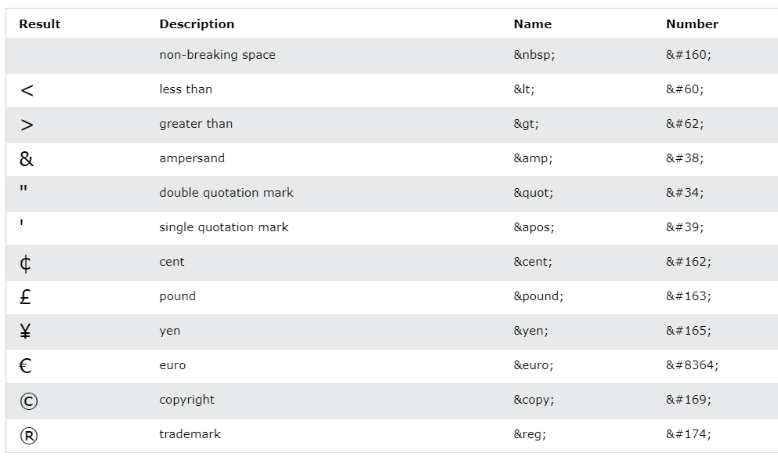

Non-breaking Space
- A commonly used HTML entity is the non-breaking space: &nbsp; A non-breaking space is a space that will not break into a new line.
- To add real spaces to your text, you can use the &nbsp; character entity.

<p>This is &nbsp; &nbsp; text.</p>

- HTML Attributes

HTML attributes provide additional information about HTML elements.

HTML Attributes
- All HTML elements can have attributes.
- Attributes provide additional information about elements.
- Attributes are always specified in the start tag.
- Attributes usually come in name/value pairs like: name="value"

Example: The style Attribute
The style attribute is used to add styles to an element, such as color, font, size, and more.

<p style="color:red;">This is a red paragraph.</p>
You will learn more attributes.

Material resources: https://www.w3schools.com/html/default.asp

